**Associate Data Analyst in SQL DataCamp**

**

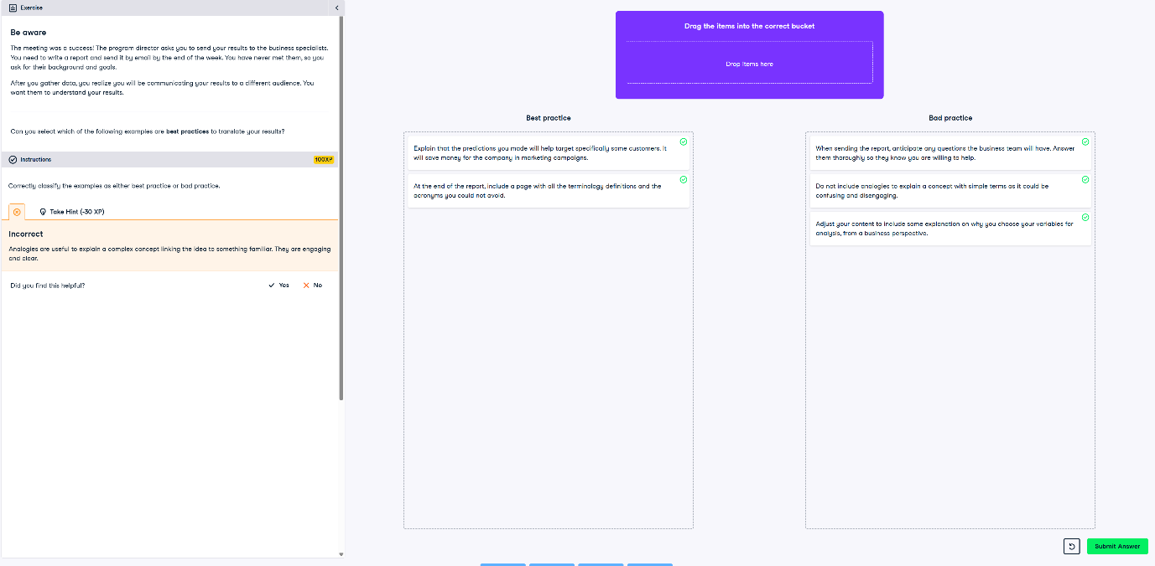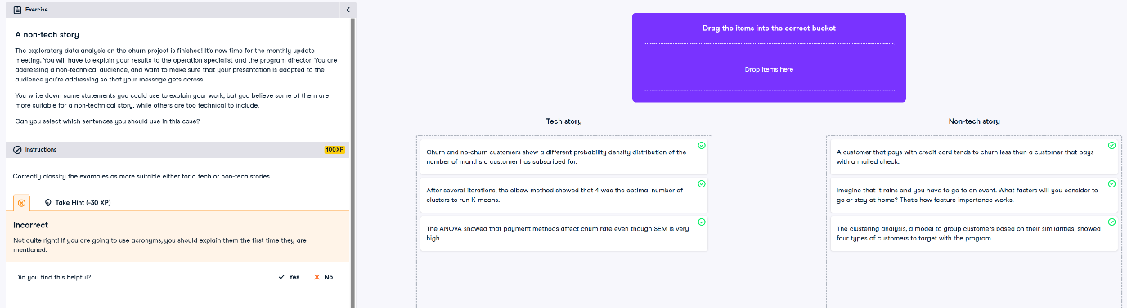

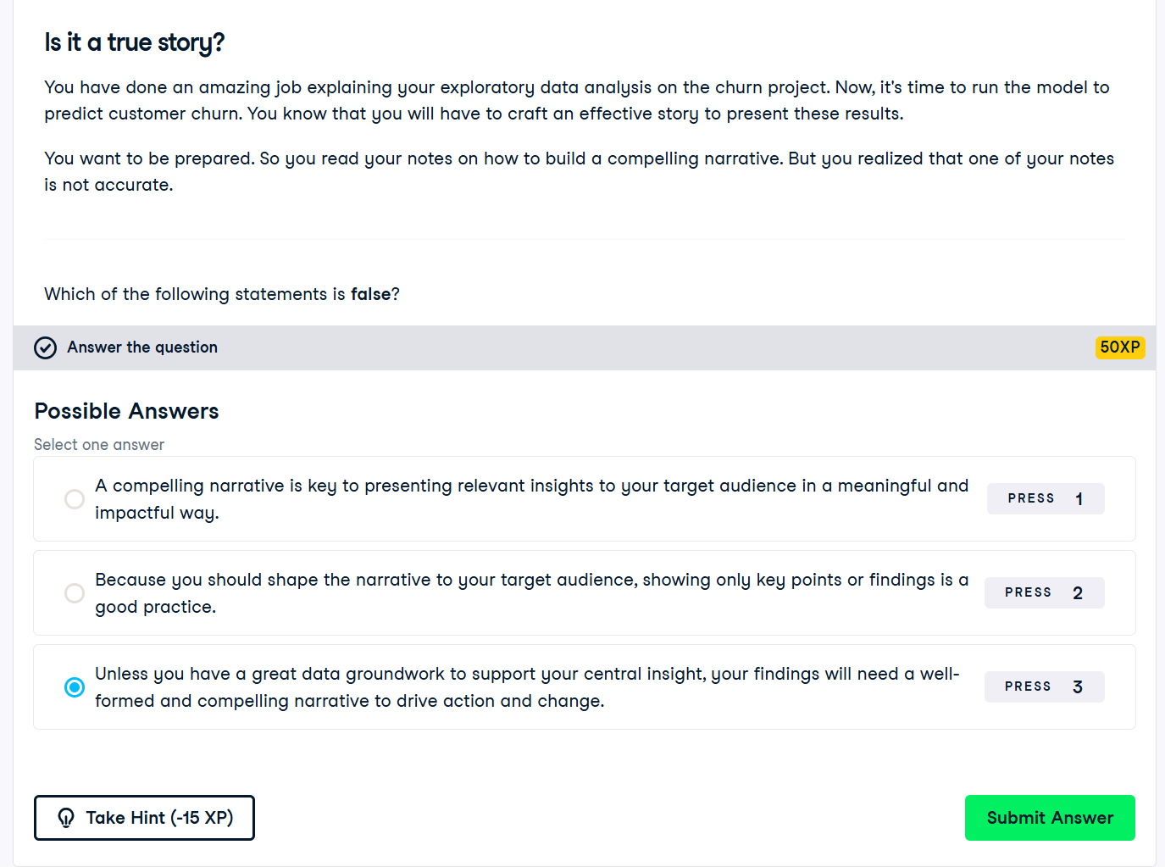

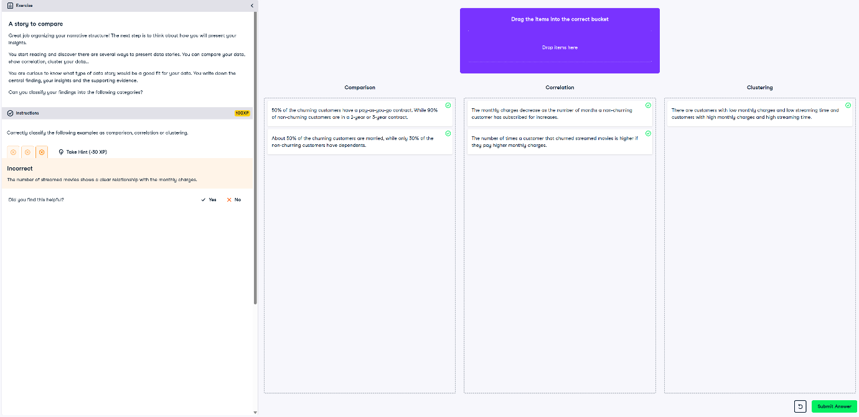

**Preparing to Communicate with Data**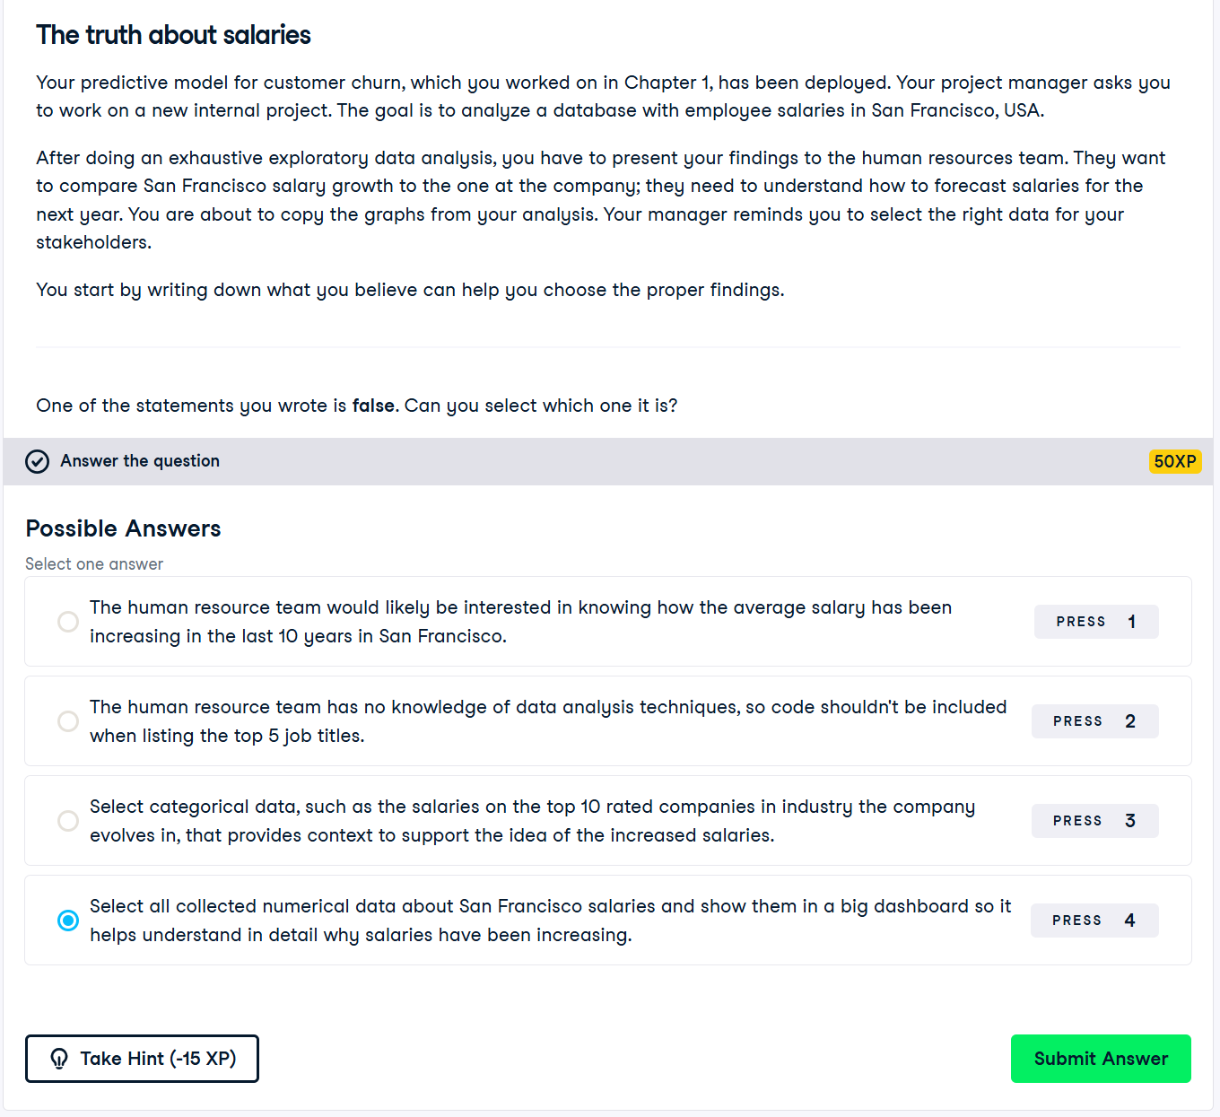

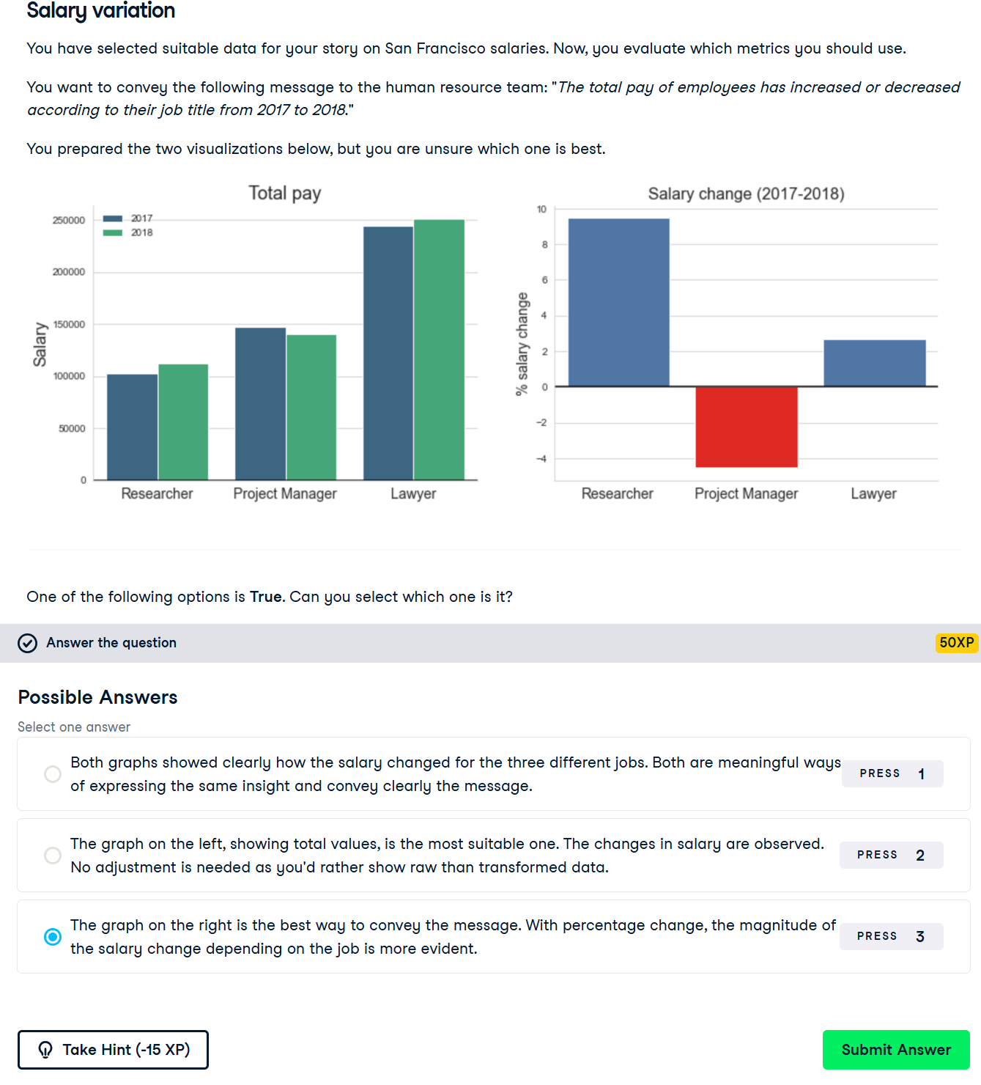

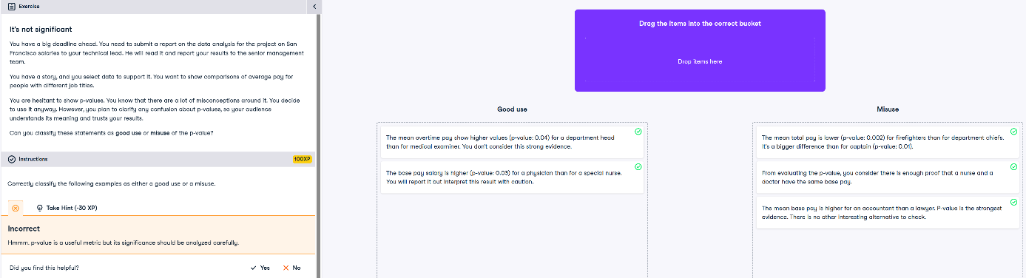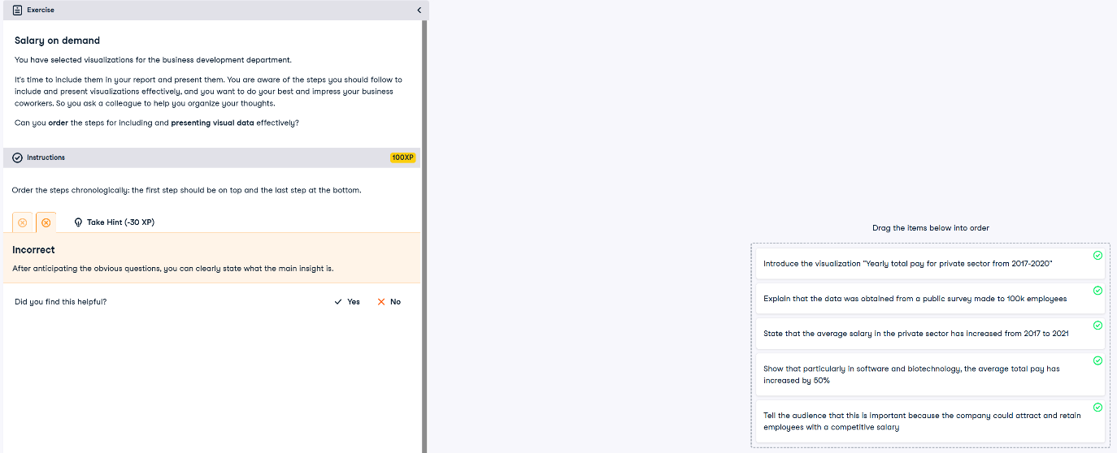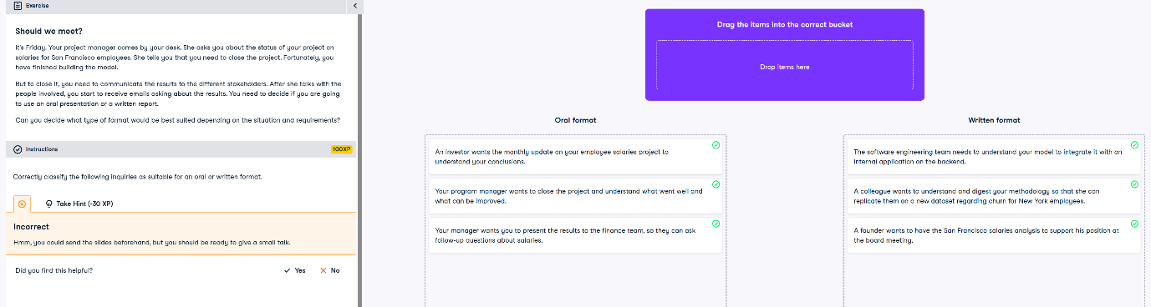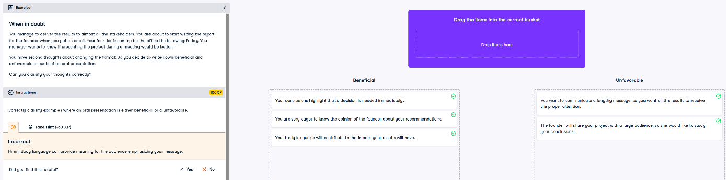

**Structuring Written Reports**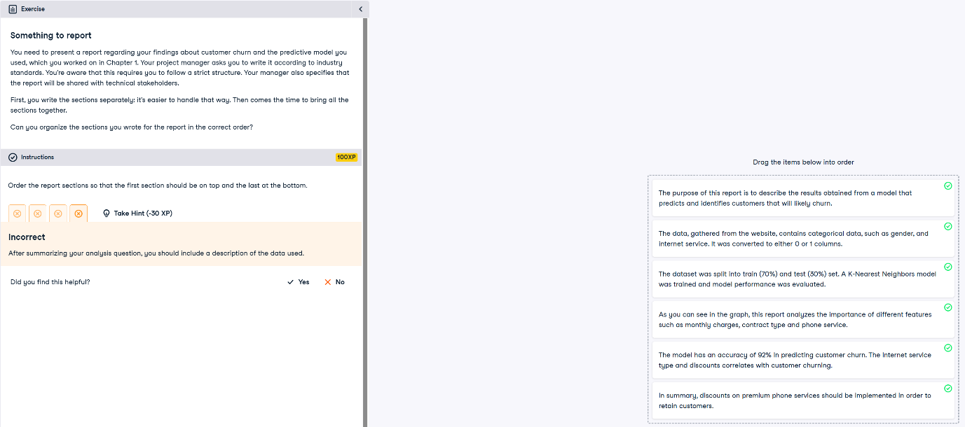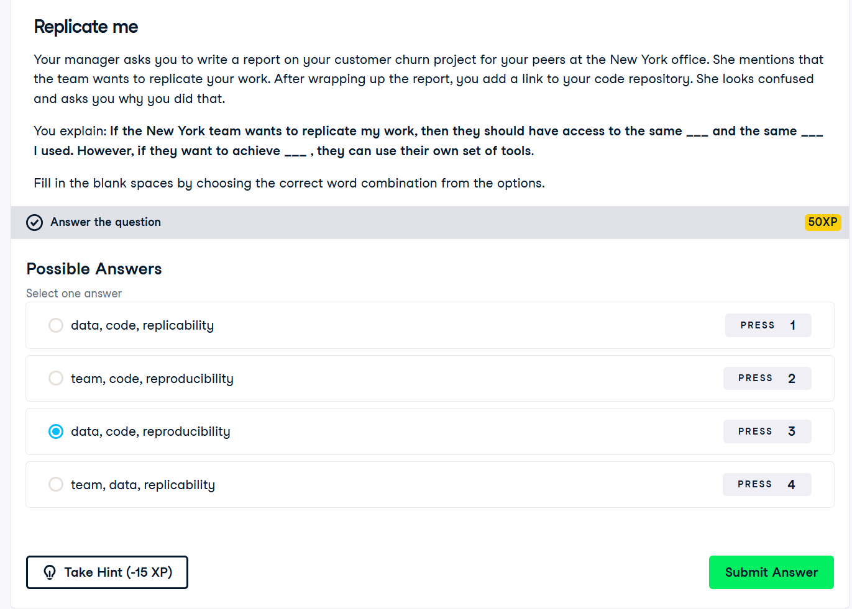

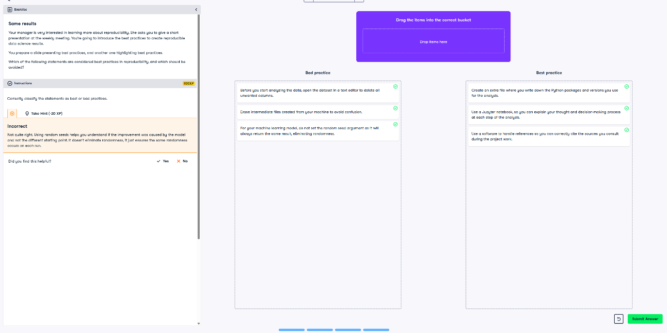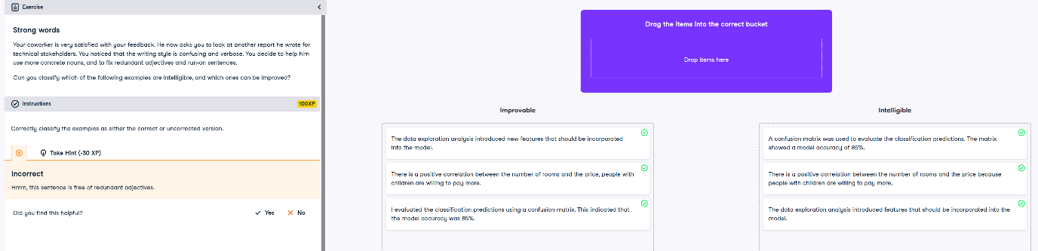

**Building Compelling Oral Presentations**

